WELCOME REMARKS

Dr. Ho Thanh My Phuong
Director, SEAMEO Regional Training Center in Vietnam
(SEAMEO RETRAC)

Distinguished Guests,
Ladies and Gentlemen,
On behalf of SEAMEO RETRAC, it is my great honor to welcome you to Ho Chi Minh City and to this annual international conference on TESOL. The conference is a joint effort between SEAMEO RETRAC and Curtin University in Australia.  English has become a global language and it has been extensively used as the medium for the world to communicate in different contexts and situations. The increased and diversified use of English has created numerous favorable conditions and advantages for both English teachers and learners. However, English teachers and | 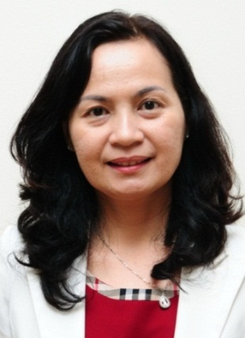
learners are also challenged by many problems and difficulties that need both short and long-term solutions. To address this issue, the theme of the 8th Conference focuses on “English Language Teaching in the 21st Century: Challenges and Opportunities”.
I am delighted with the quality and quantity of the presentations that we are able to offer to all the attendees of this year’s conference. As you can see in the conference program and proceedings, more than 60 speakers from different countries like Australia, the Philippines, Singapore, the UK, the United Stated, Vietnam, and so on, contribute to the conference with more than 50 presentations including plenary and parallel papers, workshops and poster presentations addressing key topics such as fostering learner autonomy in ELT, redefining the roles of teacher and learner in ELT, creating an engaging environment in ELT, and linking English learning in the classroom to the real world.
As usual, SEAMEO RETRAC international conference on TESOL is a forum for educators to share their ideas, innovations, experience, action research, and research findings in the national, regional and global contexts. I hope this year’s conference will pose new intellectual challenges for all of us in the field of English teaching and learning, inspire us to make exciting cross-cultural exchanges, and create dynamic networking opportunities for individuals and institutions.

Distinguished Guests,
Ladies and Gentlemen,
On this occasion, we would like to express our sincere thanks to the Vietnam’s Ministry of Education and Training and the National Foreign Languages 2020 Project for their continued guidance and support. Our special appreciation goes to Curtin University for its cooperation in academic and conference activities.
We are very grateful to the dedicated contributions of all the keynote speakers, presenters and moderators. We would like to thank the diplomatic corps and international organizations for their constant support and attendance. We would also like to thank our Platinum Sponsor: The U.S. Consulate General in Ho Chi Minh City and The U.S. Regional English Language Office in the U.S. Embassy in Ha Noi, our Gold Sponsor: British Council, our Silver sponsor: National Geographic Learning; and other Sponsors: Cambridge University Press and Dai Truong Phat Education Solutions.
We also highly appreciate the effort and contribution of all the organizing committee members and SEAMEO RETRAC’s staff who have been working so hard to make this event happen.
Finally, our special thanks goes to all of you, the participants, who will tentatively listen to presentations and heatedly make questions, discuss and share experiences with one another to make our conference the most successful one.
I hope that you fully enjoy the professional, friendly and festive moments that the Conference will provide.

